**Mild to Moderate evaluation**

Sample_ID: **PCX9TG (DOG)**

Link: <https://app.animalbiome.com/pet/assessment/report/a9258e68-b1ca-41db-8584-efa42b01c695>

Mild to Moderate

Cats and dogs:

Any Two

(High Yellow Flag Megamonas OR (failed)

High Yellow Flag Sutterella OR (**passed**)

High Yellow Flag Collinsella OR (failed)

Low Yellow Flag Bacteroides OR (failed)

Low Yellow Flag Blautia (**passed**)

OR

Dogs: 4-7 Yellow Flags: 5 (failed)

OR 5-7 Red Flags: 2 (failed)

OR diet recommendation of increase fiber (failed)

OR diet recommendation of increase protein (failed)

OR diet recommendation of decrease carbs (failed)

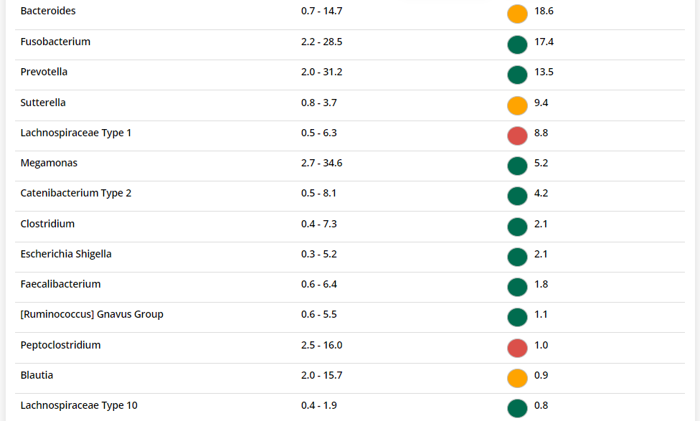

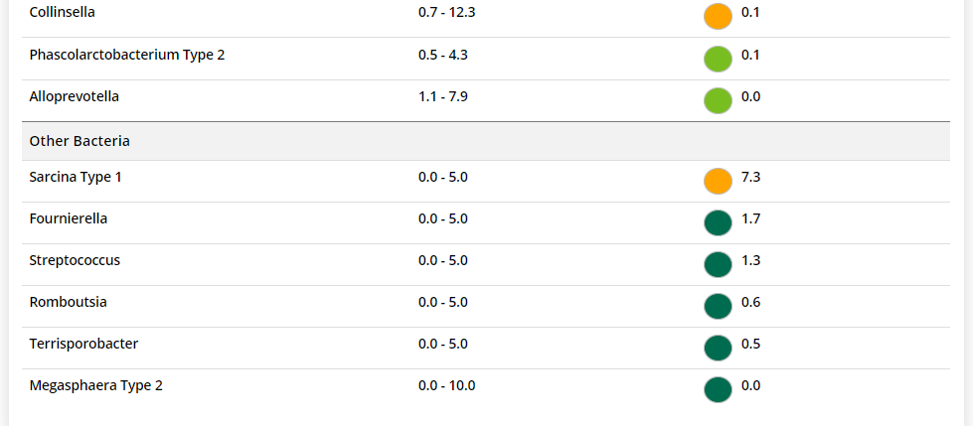



The result: **True True False False**

Expected result: Mild to Moderate

Achieved result: passed

